• Install Power BI Desktop and share the final screenshot of the report view page which appears when power desktop starts

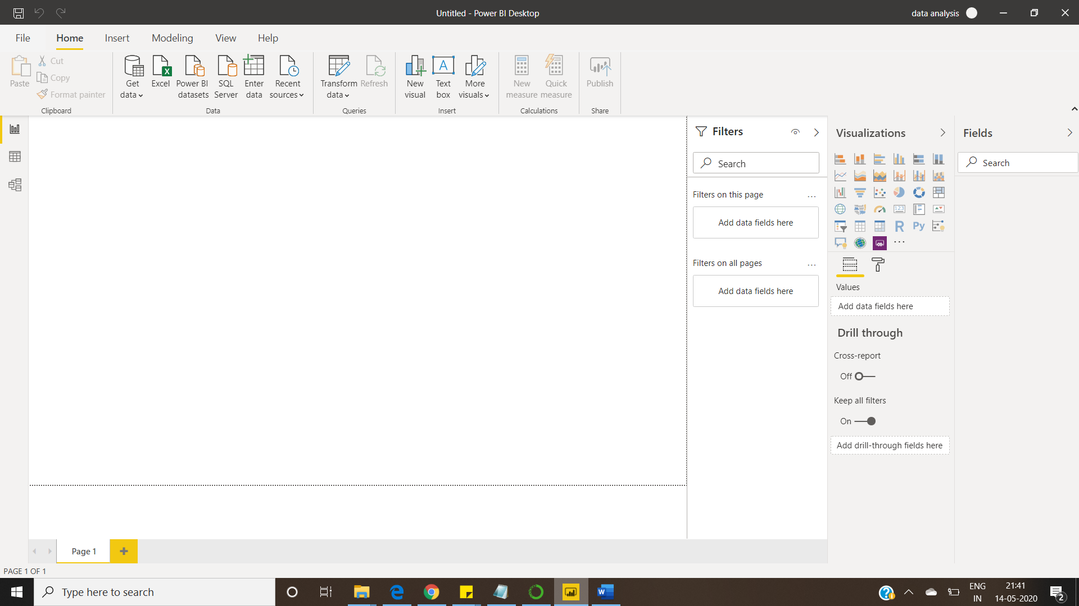

**REPORT VIEW**

**• Prepare a document and with the following screenshot**

**− Report View**



**− Data View**

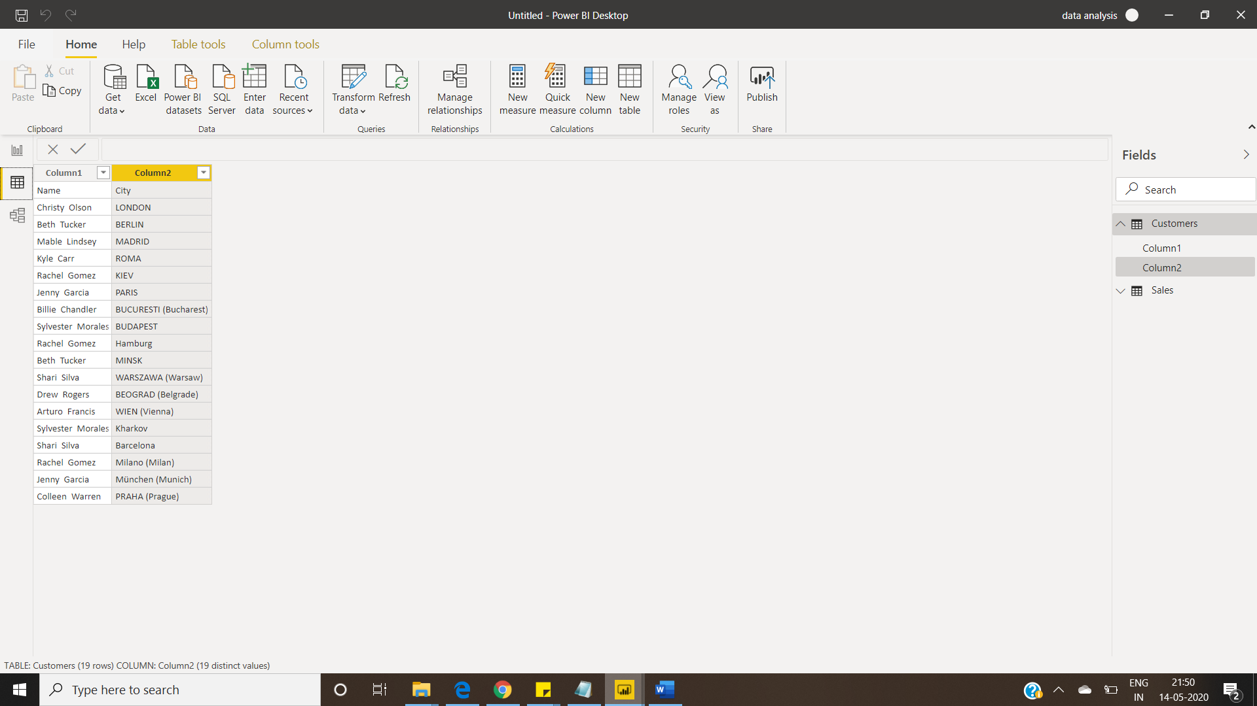

**− Model View**

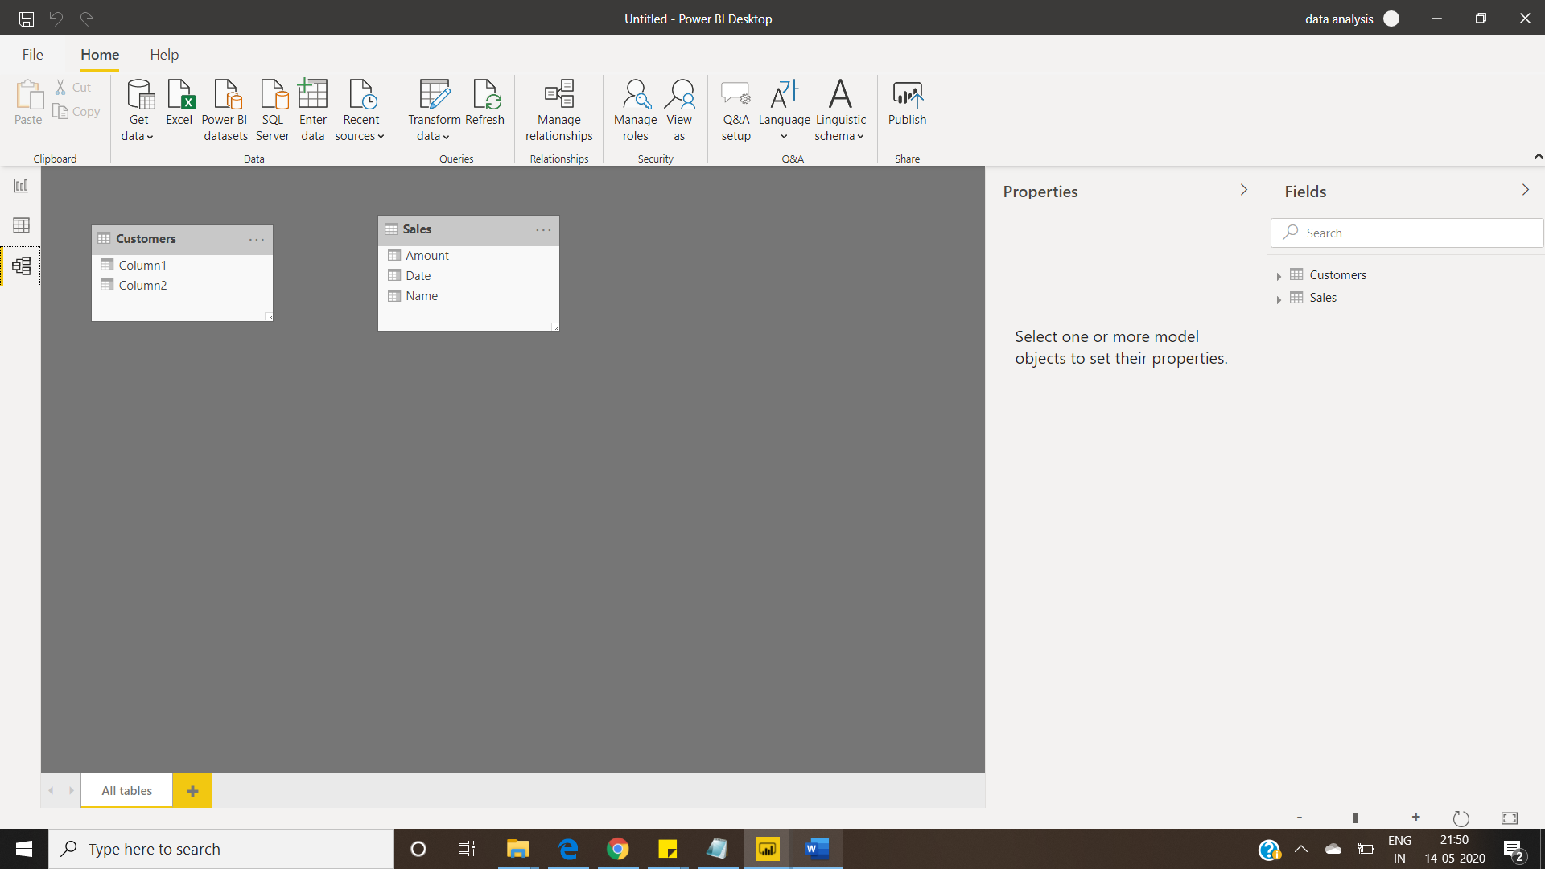

**− Power Query Editor**

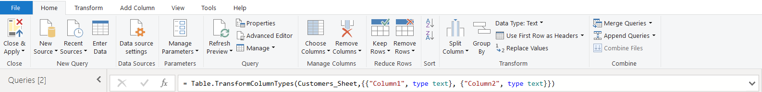

**− Advance Editor**

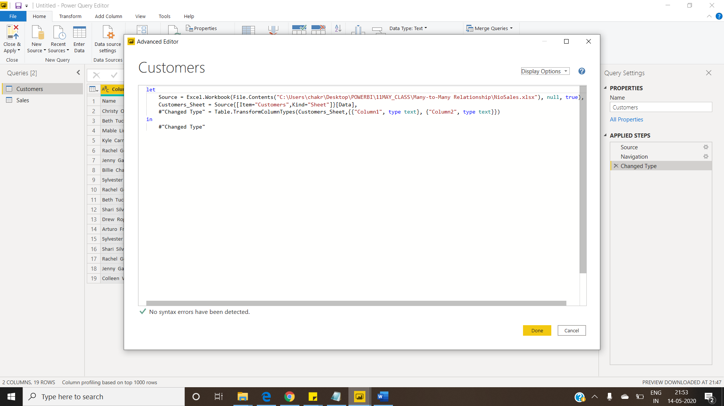

**• Prepare a document with details of the following along with their price**

**− Power BI Desktop**

free for individual users

**− Power BI Pro**

costs $9.99/Rs.660 per user per month

**− Power BI Premium**

starts at $4,995/Rs.330190 a month per dedicated cloud compute and storage resource